Name: **ZOHAIB HASSAN SOOMRO**

RollNo#: **19SW42**

Subject: **DBS**



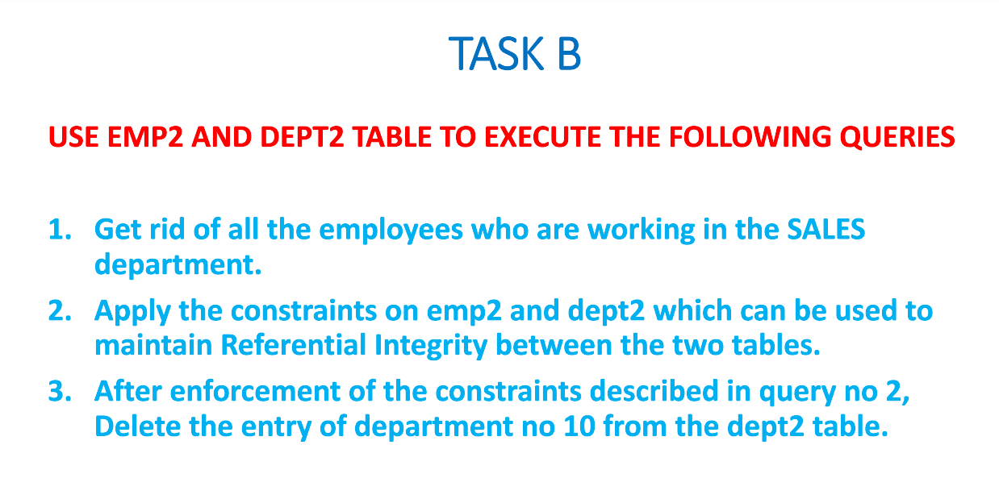



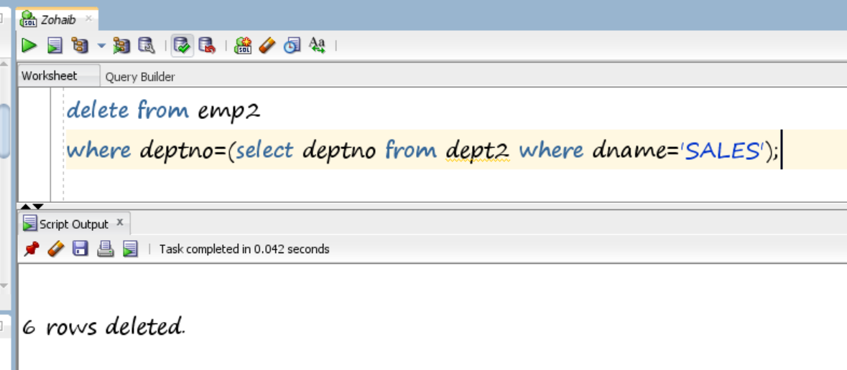



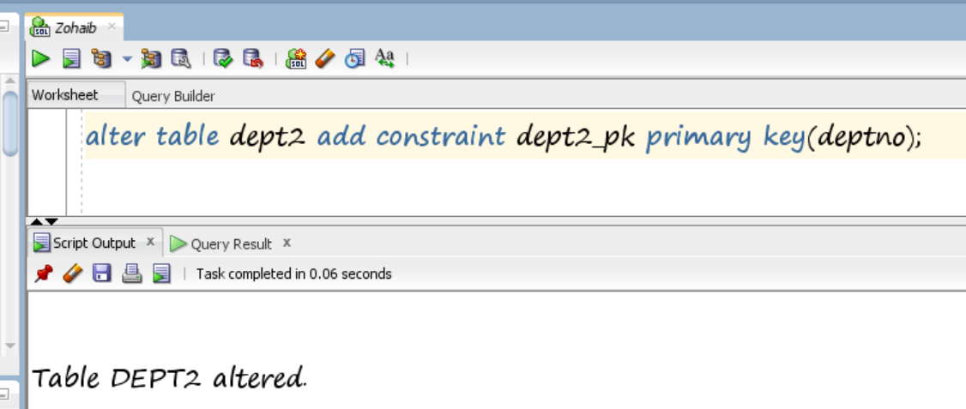

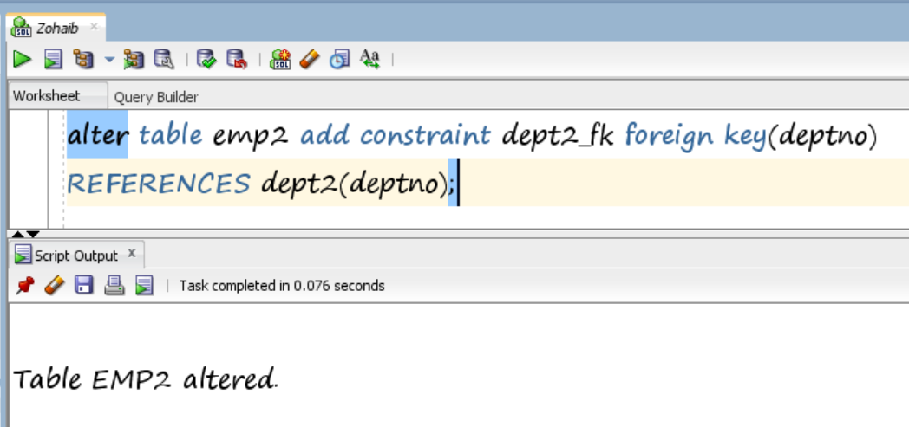

1. After enforcement of the constraints we can not delete any entry from dept2 table directly, for that, first we will need to disable the constraints

**or**

delete the employees having that entry of dept2;

1. **By deleting those employees having dept=10:**

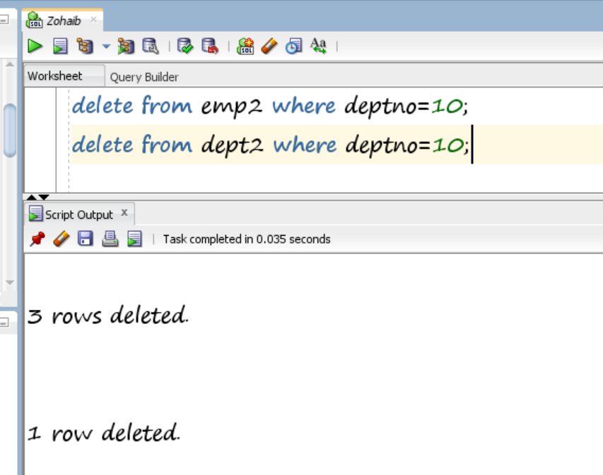

1. **By disabling(cascade) constraint:**

